​
2-Spirited People of the 1st Nations
They provide prevention education and support for 2-Spirit, including First Nations, metis and Inuit people living with or at risk for HIV and related co-infections in the Greater Toronto Area. They base their work on indigenous philosophies of wholistic health and wellness.

145 Front Street East
Suite 105
Toronto, ON M5A 1E3
Tel: 416-944-9300
www.2spirits.com

​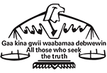
Aboriginal Legal Services
Aboriginal Legal Services’ mission is to strengthen the capacity of the Aboriginal community and its citizens to deals with justice issues and provide Aboriginal controlled and culturally based justice alternatives.

SUITE 500, 211 Yonge Street
Toronto, ON M5B 1M4
Tel: 416-408-3967
Email: alst@web.ca
www.aboriginallegal.ca

​ 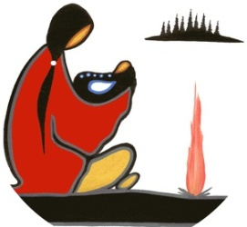
Anduhyaum Inc (Women's Shelter)

Anduhyaun Inc. is a not-for-profit, charitable agency created to respond to the needs of Toronto's Indigenous women. It was first established in 1973 as a hostel. Over the last four decades, Anduhyaun Inc. has expanded to create culturally-inclusive, safe spaces for women and their children at various stages of life.
Anduhyaun Inc.
1296 Weston Road,
Toronto, ON M6M 4R3
Tel: 416-243-7669 ext 226
anduhyaun.org

Anduhyaun Shelter
416 920 1492 ext. 221

Nekenaan Second Stage Housing
416 243 7669 ext. 226

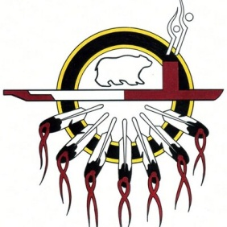
​ Anishnawbe Health Toronto
Anishnawbe Health Toronto's mission is to improve the health and well-being of Aboriginal People in spirit, mind, emotion and body by providing Traditional Healing within a multi-disciplinary health care model. They include Traditional Healers, Elders and Medicine People, Physicians, Nurses, Chiropractors, Naturopaths, FASD Workers, Massage Therapists, Traditional Counsellors, Enaadamged Kwe, Circle of Care Workers, a Psychiatrist, Chiropodist and Dentist. The model of health care at Anishnawbe Health Toronto is based on our culture and traditions. Direction is provided by a volunteer Board made up of community members. Our centre is accredited by Canadian Centre for Accreditation (CCA).

Queen Street East Location
225 Queen St E,
Toronto, ON
Tel: 416-360-0486

Gerrard Street East Location
179 Gerrard, St E,
Toronto, ON
Tel: 416-920-2605

Vaughan Road Location
22 Vaughan Rd,
Toronto, ON
Tel: 416-657-0379
www.aht.ca

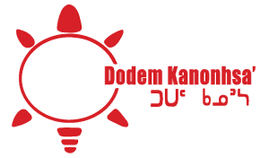

Dodem Kanonhsa'

Sharing cultural teachings, traditions and language is the purpose of the lodge. They host training sessions, circles and workshops on a variety of topics (eg. Medicine wheel teachings, etc). Elders and Traditional teachers are available twice per month to help individuals and families seeking guidance and harmony.

55 St. Clair Ave East, 6th Floor,
Toronto, ON M6H 3R9
Tel: 416-952-9272
Email: dodemkanonhsa@aandc-aadnc.gc.ca
dodemkanonhsa.ca

First Nations School of Toronto
The focus of the First Nations School is to offer a tradition-based curriculum that meets the requirements set by the Parent Council, the Toronto District School Board and the Ontario Ministry of Education. First Nations Public School is unique in that Native values, spirituality, culture and Ojibwe language are integrated throughout the school curriculum.
The goal is to ensure that urban Native children will have the opportunity to learn about their heritage and the traditional Anishinaabe cultural perspective while acquiring the skills necessary to survive in today`s world. While a large base of the student population of First Nations School is of Anishinaabe ancestry the school welcomes children of all backgrounds.

Our school currently serves students from Junior Kindergarten to Grade 8. In the 2017–18 school year, we are proud to be expanding into the secondary school grades. In September 2017, we will be welcoming our first class of Grade 9 students.
16 Phin Ave,
Toronto, ON M4J 3T2
Tel: 416-393-0555
schoolweb.tdsb.on.ca/FNST

Gabriel Dumont Non-Profit Homes
4201 Kingston Road,
Scarborough, ON
M1E 5B3

416-286-5277
Geared to income, 87-unit apartment and townhouse complex.

Miziwe Biik Aboriginal Employment and Training
Miziwe Biik Aboriginal Employment and Training's mission is to provide services to the First Nations (status & non-status), Inuit, and Metis peoples in the Greater Toronto Area; to work with employers to secure employment opportunities; to deliver federal and provincial programs; and, promote First Nations (status & non-status), Inuit, and Metis entrepreneurship and the development of our economies. We will work with individuals, other agencies and groups to provide these services and achieve our mission.

167 Gerrard Street East
Toronto, ON M5A 2E4
Tel: 416-591-2310
Email: reception@miziwebiik.com
www.miziwebiik.com

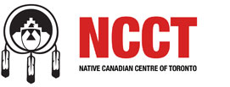
Native Canadian Centre of Toronto
The Native Canadian Centre of Toronto is a membership-based, charitable organization located in the heart of downtown Toronto in a beautifully renovated heritage building. NCCT offers a wide range of programs and services based on Indigenous cultural traditions and teachings. All are welcome.

16 Spadina Road
Toronto, ON M5R 2S7
Tel: 416-964-9087
Email: reception@ncct.on.ca
www.ncct.on.ca

​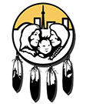
Native Child and Family Services of Toronto
Native Child and Family Services strives to provide for a life of quality, well being, caring and healing for children and families in the Toronto Native community. It does this by creating a service model that is culture-based, respecting the values of Native peoples, the extended family and the right to self-determination. They serve Native families and children in the Toronto area, including First Nations, Métis, Inuit and all those with Aboriginal heritage who choose to be served by our Agency.

NCFST offers a wide range of services including youth and women’s transitional homes, childcare/Aboriginal Head Start sites etc. across the city and many other child and family services and programs.

30 College Street
Toronto, ON M5G 1K2
Tel: 416-969-8510
Email: info@nativechild.org
www.nativechild.org

Native Youth Resource Centre (NYRC)
NCFST youth program staff are available to provide individual counselling, support and advocacy in the areas of housing, welfare, employment and legal help. Youth are invited to spend time at the centre and in doing so engage with one of our staff in finding the assistance they need.

655 Bloor St. W.,
Toronto, ON M6G 1L1
416-969-8510

​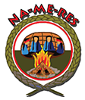
Na-Me-Res (Native Men’s Residence)
The Na-Me-Res team meets the physical, mental, spiritual, and emotional needs of their clients wherever they are on their journey. They are traditional Elders & teachers, case managers, counsellors, client care and support workers, street outreach workers, housing support and aftercare workers, Registered Nurses, Oshkabaywis (spiritual helpers), and a life skills coordinator. Na-Me-Res also partners with psychiatrists, doctors, and many other community service providers.
Today, the Na-Me-Res Housing initiatives include: 69-bed emergency shelter, transitional housing program, and a long-term independent housing initiative

14 Vaughan Rd.
Toronto, ON M6G 2N1
Tel: 416-652-0334
Email: general@nameres.org
www.nameres.org
​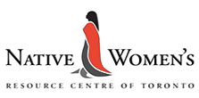
Native Women’s Resource Centre of Toronto
Native Women's Resource Centre of Toronto supports urban Aboriginal women and children from all walks of life. They build self-sufficiency and develop collective capacity to make positive change. They provide individual support, group programming, and cultural initiatives. Native Women’s Resource Centre of Toronto provides a safe and welcoming environment for all Aboriginal women and their children in the Greater Toronto Area. Their programs fall under six broad categories: Housing, Families, Advocacy, Employment, Education, and Youth.

191 Gerrard Street East
Toronto, ON M5A 2E5
Tel: 416-963-9963
Email: info@nwrct.ca
www.nwrct.ca

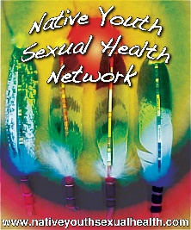

Native Youth Sexual Health Network (NYSHN)

The Native Youth Sexual Health Network (NYSHN) is an organization by and for Indigenous youth that works across issues of sexual and reproductive health, rights and justice throughout the United States and Canada.

Native Youth Sexual Health Network
2345 Yonge St.
PO Box 26069 Broadway
Toronto, Ontario
Canada
M4P 0A8
​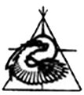
Nishnawbe Homes
For the many Aboriginal singles coming to Toronto for opportunities, education or jobs, Nishnawbe Homes offers affordable housing that connects them to the community and reflects First Nations culture and values. Nishnawbe Homes owns 15 properties. Their goal is to promote a safe, affordable and co-operative lifestyle for underhoused and homeless Aboriginal people.

244 Church Street
Toronto ON M5B 1Z3
Tel: 416-975-5451
Email: nishnawbehomes@rogers.com

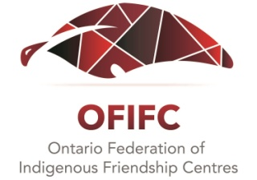
Ontario Federation of Indigenous Friendship Centres (OFIFC)
The Ontario Federation of Indigenous Friendship Centres (OFIFC) is a provincial Indigenous organisation representing the collective interests of member Friendship Centres located in towns and cities across the province. Friendship Centres are not-for-profit corporations which are mandated to serve the needs of all Indigenous people regardless of legal definition, and are the primary service delivery agents for Indigenous people requiring culturally-sensitive and culturally-appropriate services in urban communities.

The vision of the Friendship Centre movement is to “improve the quality of life for Indigenous people living in an urban environment by supporting self-determined activities which encourage equal access to and participation in Canadian society and which respect Indigenous cultural distinctiveness”.

219 Front Street East,
Toronto ON M5A 1E8
Tel: 416-956-7575
Toll free: 1-800-772-9291
Fax: 416-956-7577
Email: ofifc@ofifc.org

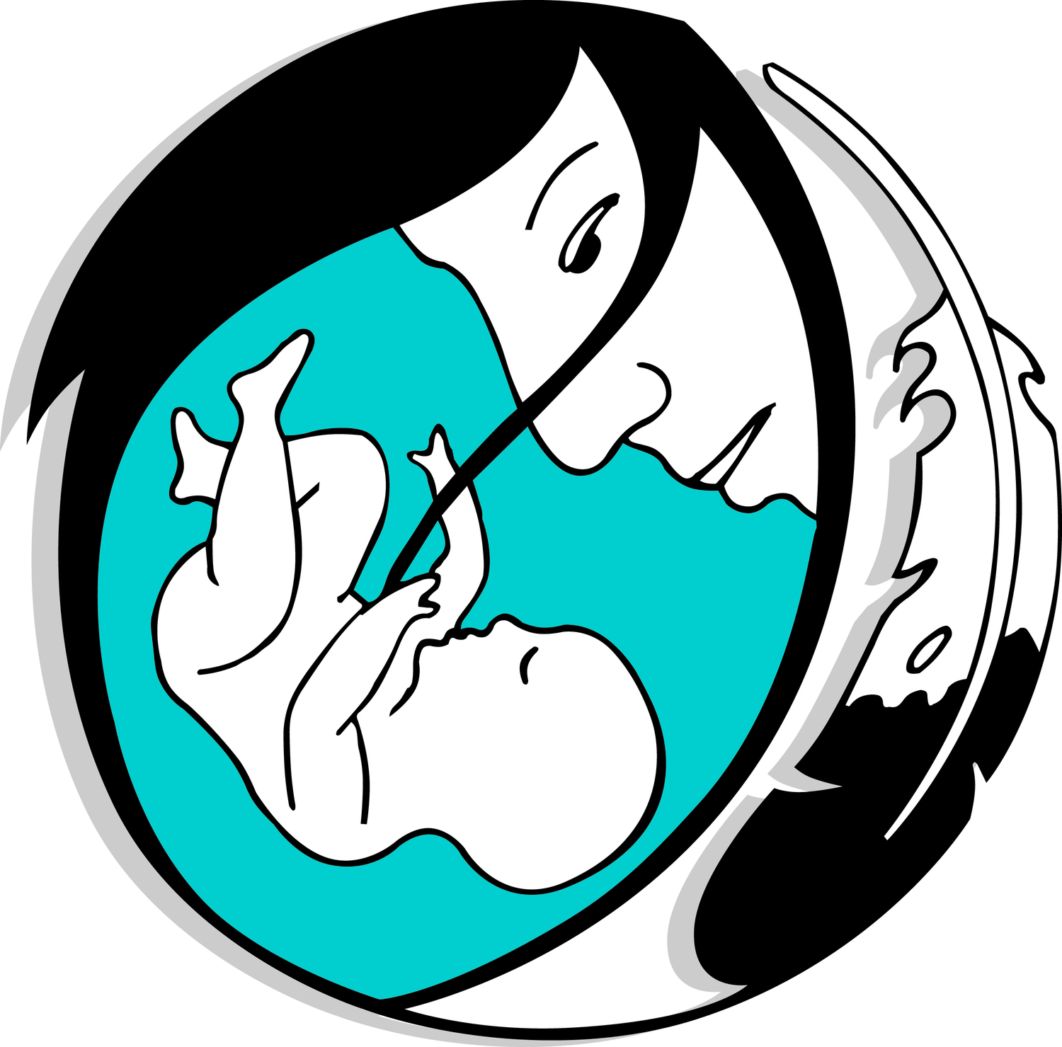
Seventh Generation Midwives Toronto (SGMT)

Seventh Generation Midwives Toronto (SGMT) is a group of midwives who offer maternity care to women from the City of Toronto, particularly those from the downtown area, and from the Aboriginal community. We have privileges at Sunnybrook Health Sciences Centre and the Toronto Birth Centre. We provide midwifery care throughout pregnancy, labour, birth, and the first 6 weeks postpartum.

Seventh Generation Midwives Toronto believes in the sacredness of all life, and respects the beauty and power of nature and creation. We believe that birth is a profound and awesome event in a woman’s life. We take into account the spiritual, emotional, mental and physical experiences of the woman during her childbearing year.

We seek to improve the health and well being of families from diverse cultures in the Toronto area. We envision maternity care for the Aboriginal community that enables women to reclaim control of birth for themselves, including the choice to incorporate traditional teachings and ceremonies. Our work as midwives belongs to and serves the woman, her family, and her community. We aspire to support and mentor more members of the Aboriginal community to enter into health professions, including Midwifery.
525 Dundas St. East, 2nd Floor,
Toronto ON M5A 2B6
Tel: 416-530-7468
Fax: 416-530-7478
www.sgmt.ca

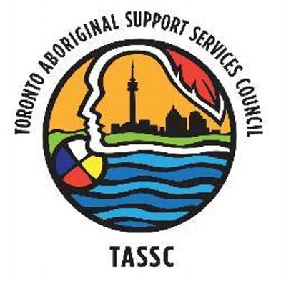
Toronto Aboriginal Support Services Council (TASSC)

TASSC is the leading not-for-profit research, policy, and advocacy organization that addresses the social determinants of health to improve and enhance the socio-economic prospects and cultural well-being of Aboriginal peoples living in the City of Toronto. Their vision is to build a healthy and vibrant environment while increasing the capacity of Aboriginal people to create a self-sufficient community in Toronto. To guide future generations as strong carriers of Aboriginal culture while achieving socio-economic success.

16 Spadina Road, 2nd Floor
Toronto, ON M5R 2S7
www.tassc.ca

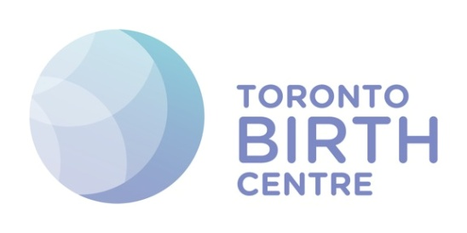
Toronto Birth Centre

The vision of the Toronto Birth Centre is to be a space where pregnant people, families and communities can access safe and culturally respectful birthing care. The purpose of the Toronto Birth Centre Inc. is to achieve optimal health and wellness for the whole community through culturally integrated care, education and research, and through supporting the practice of Aboriginal midwifery in its fullest scope both culturally and professionally.

525 Dundas St E,
Toronto, ON M5A 2B6
Tel: 416-366-8080
Fax: 416-366-8050
www.torontobirthcentre.ca

​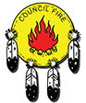
Toronto Council Fire Native Cultural Centre
Toronto Council Fire Native Cultural Centre is an autonomous, vibrant cultural agency that involves and serves the Indigenous community with confidence for and commitment to their well-being. The center provides counselling, material assistance and other direct services to First Nations people as well as to encourage and enhance spiritual and personal growth..

439 Dundas Street East
Toronto, ON M5A 2B1
Tel: 416-360-4350
Email: cdo@councilfire.ca
www.councilfire.ca
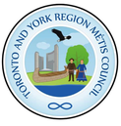
Toronto and York Region Métis Council
As part of the Métis Nation, we represent Métis people in Toronto and York Regions. We aspire to provide cultural events, education and build healthy and reciprocal relationships in the spirit of reconciliation. Their vision is that Métis people and the community of Toronto and York Region are thriving, culturally vibrant and woven together like the threads of our sash. ​

311-75 Sherbourne St.
​Toronto, M5A 2P9
Tel: ​416-977-9881
Email: council@tyrmc.org
http://www.torontoyorkmetis.com/home.html

Wigwamen

Founded in 1972, Wigwamen Incorporated, a non-profit and charitable organization, is Ontario’s oldest and largest urban Aboriginal housing provider. With 214 units scattered throughout the City of Toronto, a 92-unit apartment building for families and singles in Scarborough, a 60-unit apartment building in Northeast Scarborough, a 103-unit apartment complex for seniors in downtown Toronto, a new nine-unit apartment building in Toronto, a 41-unit apartment building in Ottawa, and now a new 145-unit apartment building in the Canary District of Toronto, Wigwamen is committed to providing decent, safe and affordable housing to thousands of Aboriginal and non-Aboriginal families, singles and seniors.

WIGWAMEN'S HEAD OFFICE:
23 Lesmill Road
Unit 106
Toronto ON M3B 3P6
Tel: 416-481-4451
Fax: 416-481-5002

